Selective Esterifications of Alcohols and Phenols through Carbodiimide Couplings
Rimma Shelkov, Moshe Nahmany and Artem Melman*
Supplementary information.
Table of content.

A. Characterization data for new compounds and references for
known compounds Pages S2-S9
B. ¹H NMR 300 MHz spectra of new compounds
6a S10
6b S11
8a S12
8b S13
9a S14
9b S15
10a S16
11a S17
12a S18
12b S19
13a S20
23c S21
24d S22
33d S23

General.
All the reactions were performed in acetonitrile that were dried and distilled by standard procedures. The ¹H spectra were acquired by Bruker AMX-300 and DRX-400 MHz instruments in CDCl₃ using the residual solvent peak for calibration. IR spectra were recorded on FT-IR spectrometer in thin films.

Methyl diethylphosphonoacetate (4a). Aldrich NMR Library (60 MHz) Second Ed. 2, 869D. Smith, P.; Brown, L.; Boutagy, J.; Thomas, R. J. Med. Chem. 1982, 25, 1222-1226.
Methyl ethylmalonate (4b). Sato, M.; Ban, H.; Kaneko, C. Tetrahedron Lett. 1997, 38, 6689-6692..
2-Bromoethyl diethylphosphonoacetate (5a). Prepared according to general procedure A (0.28 g, 91%). ¹H NMR (300 MHz): 1.33 (t, J=7.2 Hz, 6H); 2.98 (d, J=21.6 Hz, 2H); 3.48 (t, J=6.3 Hz, 2H); 4.16 (quint., J=7 Hz, 4H); 4.42 ( t, J=6.3 Hz, 2H). ¹³C (75.48 MHz): 16.0 (d, J=9 Hz), 27.8, 33.7 (d, J=133 Hz), 62.5 (d, J=6 Hz), 64.4, 165 (d, J=6 Hz). Found C, 31.9; H, 5.2. Calc. for C₈H₁₆BrO₅P: C, 31.7; H, 5.3%.
2-Bromoethyl ethyl malonate (5b). Prepared according to general procedure A (0.22 g, 93%, ¹H NMR (300 MHz): 1.30 (t, J=7.1 Hz, 3H); 3.43 (s, 2H); 3.53 (t, J=6.1 Hz, 2H); 4.24 (q., J=7.1 Hz, 2H); 4.46 (t, J=6.1 Hz, 2H). ¹³C (75.48 MHz): 14.0, 28.0, 41.3, 61.6, 64.6, 166.08, 166.12. Found C, 35.1; H, 4.9. Calc. for C₇H₁₁BrO₄: C, 35.2; H, 4.6%.
2-Ethoxyethyl diethylphosphonoacetate (6a). Prepared according to general procedure A (0.24 mg, 89%). ¹H NMR (300 MHz): 1.12 (t, J=7.0 Hz, 3H); 1.27 (t, J=7.1 Hz, 6H); 2.94 (d, J=21.5 Hz, 2H); 3.45 (q, J=7.0 Hz, 2H); 3.57 (br. t, J=4.8 Hz, 2H); 4.16 (quint., J=7 Hz, 4H); 4.20 (br. t, J=4.8 Hz, 2H). ). ¹³C NMR (75.48 MHz): 14.4, 15.6 (d, J=6 Hz), 32.6, 34.3, 62.0 (d, J=7 Hz), 64.0, 65.8, 67.4, 165.0 (d, J=6 Hz).
2-Ethoxyethyl ethyl malonate (6b). Prepared according to general procedure A (0.17 g, 86%). ¹H NMR (300 MHz): 1.21 (t, J=7.0 Hz, 3H); 1.29 (t, J=7.1 Hz, 3H); 3.42 (s, 2H); 3.53 (q, J=7.0 Hz, 2H); 3.66 (m, 2 H); 4.21 (q., J=7.1 Hz, 2H); 4.30 (m, 2H). ¹³C NMR (75.48 MHz): 14.0, 15.0, 41.5, 61.5, 64.6, 66.6, 68.0, 166.4, 166.7.
Phenyl diethylphosphonoacetate (7a). Morita, T.; Okamoto, Y.; Sakurai, H. Bull. Chem. Soc. Jpn. 1978, 51, 2169-2170.
Phenyl ethylmalonate (7b). ): 1.31 (t, J=7.3 Hz, 3H), 3.62 (s, 2H), 4.28 (q, J=7.3 Hz, 2H), 7.14 (m, 2H), 7.27 (m, 1H), 7.40 (m, 2H). 15162-26-2. Osman, A. M.; Swelim, A. A.; Ismail, M. T. Bull. Fac. Sci., Assiut Univ. 1979, 4, 153-157
4-Methoxyphenyl diethylphosphonoacetate (8a). Prepared according to general procedure A (0.21 g, 69%). ¹H NMR (300 MHz):1.36 (t, J=6.9 Hz, 6H); 3.17 (d, J=21.6 Hz, 2H); 3.79 (s, 3H); 4.22 (app. quint, J=7 Hz, 4H); 6.87, 7.02 (2xapp. d, J=7 Hz, 2x2H).
4-Methoxyphenyl ethyl malonate (8b). Prepared according to general procedure A (0.15 g, 61%, 1.30 (t, J=7.2 Hz, 3H); 3.59 (s, 2H); 3.79 (s, 3H); 4.23 (q, J=7.2 Hz, 2H); 6.89, 7.02 (2xapp. d, J=7 Hz, 2x2H).
4-Cyanophenyl diethylphosphonoacetate (9a). Prepared according to general procedure A. 1.38 (t, J=7.0 Hz, 6H); 3.24 (d, J=21.8 Hz, 2H); 4.22 (app. quint., J=7 Hz, 4H); 7.27, 7.71 (2xapp. d, J=7 Hz, 2x2H).
4-Cyanophenyl ethyl malonate (9b). Prepared according to general procedure A. ¹H NMR (300 MHz): 1.31 (t, J=7.2 Hz, 3H); 3.62 (s, 2H); 4.26 (q, J=7.2 Hz, 2H); 7.26, 7.69 (2xapp. d, J=7 Hz, 2x2H).
4-Nitrophenyl diethylphosphonoacetate (10a). Prepared according to general procedure A. ¹H NMR (300 MHz):1.38 (t, J=7.0 Hz, 6H); 3.23 (d, J=21.6 Hz, 2H); 4.24 (app. quint., J=7 Hz, 4H); 7.33, 8.28 (2xapp. d, J=7 Hz, 2x2H).
4-Nitrophenyl ethylmalonate (10b). 1.33 (t, J=7.2 Hz, 3H); 3.65 (s, 2H); 4.28 (q, J=7.2 Hz, 2H); 7.32, 8.29 (2xapp. d, J=7 Hz, 2x2H). Isaacs, N. S.; Najem, T. S. J. Chem. Soc., Perkin 2 1988, 557-562.
2,4,6-Trichlorophenyl diethylphosphonoacetate (11a). Prepared according to general procedure A. ¹H NMR (300 MHz): 1.31 (t, J=7.2 Hz, 6H); 3.27 (d, J=21.6 Hz); 4.24 (quint, J=7 Hz, 4H); 7.38 (s, 2H).
2,4,6-Trichlorophenyl ethyl malonate (11b). Prepared according to general procedure A. ¹H NMR (300 MHz): 1.32 (t, J=7.2 Hz, 3H); 3.70 (s, 2H); 4.28 (q, J=7.2 Hz, 2H); 7.39 (s, 2H). Found C, 42.6; H, 3.0. Calc. for C₁₁H₉Cl₃O₄: C, 42.4; H, 2.9;
Pentafluorophenyl diethylphosphonoacetate (12a). Prepared according to general procedure A. ¹H NMR (300 MHz): 1.38 (t, J=7.2 Hz, 6H); 3.27 (d, J=21.9 Hz); 4.24 (quint, J=7 Hz, 4H).
Pentafluorophenyl ethyl malonate (12b). Prepared according to general procedure A. ¹H NMR (300 MHz): 1.33 (t, J=7.2 Hz, 3H); 3.71 (s, 2H); 4.28 (q, J=7.2 Hz, 2H).
Pentachlorophenyl diethyl phosphonoacetate (13a). Prepared according to general procedure A. ¹H NMR (300 MHz): 1.38 (t, J=7.2 Hz, 6H); 3.30 (d, J=21.9 Hz); 4.24 (quint, J=7 Hz, 4H). Found C, 32.25; H, 2.9. Calc. for C₁₂H₁₂Cl₅O₅: C, 32.4; H, 2.7%.
Pentachlorophenyl ethyl malonate (13b). 1.37 (t, J=7.1 Hz, 3H); 3.72 (s, 2H); 4.29 (q, J=7.1 Hz, 2H). Bienert, M.; Kuehler, M.; Bergmann, J.; Mehlis, B.; Niedrich, H. Patent Ger. (East) 1974, DD107947.
o-Cresyl diphenylacetate (21c): Prepared according to general procedure D (0.14 g, 45%). 3.79 (s, 3H); 5.29 (s, 1H), 6.9-7.4 (m, 14H); Found C, 83.1; H, 6.1. Calc. for C₂₁H₁₇O₂: C, 83.4; H, 6.0%.
o-Cresyl ω-undecenoate (21d): Prepared according to general procedure D (0.145 g, 53%). 1.0-1.4 (m, 10H); 1.68 (br. q. 2H); 2.0-2.1 (br.q., 2H); 2.25 (s, 3H); 2.53 (t, 2H, J=7.3 Hz); 4.94 (br. d, 1H, J=10 Hz); 5.00 (br. d, 1H, J=18 Hz); 5.79 (ddt, 1H, J=10, 18, 7 Hz); 6.7-6.9 (m, 2H); 7.0-7.1 (m, 2H). Found C, 78.1; H, 9.4. Calc. for C₁₈H₂₆O₂: C, 78.8; H, 9.55%.
4-Methoxyphenyl diphenylacetate (22c). 71%; 3.78 (s, 3H); 5.24 (s, 1H); 6.85 (d, 2H, J= 9.2 Hz); 6.96 (d, 2H, J= 9.2 Hz); 7.10-7.40 (m, 10H). Do Amaral, A. T.; Do Amaral, L, J. Org. Chem. 1976, 41, 1623-1627.
4-Methoxyphenyl ω-undecenoate (22d). Prepared according to general procedure D (0.21 g, 73%). 1.0-1.4 (m, 10H); 1.68 (br. q. 2H); 2.0-2.1 (br.q., 2H); 2.53 (t, 2H, J=7.4 Hz); 3.79 (s, 3H); 4.94 (br. d, 1H, J=10 Hz); 5.00 (br. d, 1H, J=18 Hz); 5.79 (ddt, 1H, J=10, 18, 7 Hz); 6.87 (d, 2H, J=9 Hz); 7.68 (d, 2H, J=9 Hz). Found, C, 74.3; H, 9.15. Calc. for C₁₈H₂₆O₃: C, 74.45; H, 9.0%.
4-Cyanophenyl diphenylacetate (23c). Prepared according to general procedure D (0.28 g, 90%). 5.28 (s, 1H); 7.10-7.40 (m, 12H); 7.53 (d, 2H, J=8.9 Hz).
4-Cyanophenyl ω-undecenoate (23d). Prepared according to general procedure D (0.27 g, 95%). 1.0-1.4 (m, 10H); 1.68 (br. q. 2H) 2.0-2.1 (br.q., 2H); 2.58 (t, 2H, J=7.4 Hz); 4.94 (br. d, 1H, J=10 Hz); 5.00 (br. d, 1H, J=18 Hz); 5.79 (ddt, 1H, J=10, 18, 7 Hz); 7.22 (d, 2H, J=8.7 Hz); 7.68 (d, 2H, J=8.7 Hz); Found C, 75.65; H, 8.35; N, 5.0. Calc. for C₁₈H₂₃NO₂: C, 75.8; H, 8.1; N, 4.9%.
2,4,6-Trichlorophenyl diphenylacetate (24c). Prepared according to general procedure D (0.35 g, 88%). 5.40 (s, 1H); 7.20-7.40 (m, 12H). Found C, 61.5; H, 3.4. Calc. for C₁₀H₁₃Cl₃O₂: C, 61.3; H, 3.3%.
2,4,6-Trichlorophenyl ω-undecenoate (24d). Prepared according to general procedure D (0.35 g, 94%; 1.0-1.4 (m, 10H); 1.68 (br. q. 2H); 2.0-2.1 (br.q., 2H); 2.66 (t, 2H, J=7.4 Hz); 4.94 (br. d, 1H, J=10 Hz); 5.00 (br. d, 1H, J=18 Hz); 5.79 (ddt, 1H, J=10, 18, 7 Hz); 7.38 (s, 2H).
4-Nitrophenyl diphenylacetate (25c). Prepared according to general procedure D (0.30 g, 90%). 5.31 (s, 1H); 7.20-7.40 (m, 12H); 7.53 (d, 2H, J=8.9 Hz). Found C, 72.2; H, 5.0; N, 3.7. Calc. for C₁₆H₁₅NO₄: C, 72.1; H, 4.5; N, 4.2%.
4-Nitrophenyl ω-undecenoate (25d). Prepared according to general procedure D (0.30 g, 98%). 1.0-1.4 (m, 10H); 1.68 (br. q. 2H); 2.0-2.1 (br.q., 2H); 2.59 (t, 2H, J=7.8 Hz); 4.94 (br. d, 1H, J=10 Hz); 5.00 (br. d, 1H, J=18 Hz); 5.79 (ddt, 1H, J=10, 18, 7 Hz); 7.27 (d, 2H, J=7.8 Hz); 8.26 (d, 2H, J=7.8 Hz). Found C, 67.15; H, 7.7, N, 4.4. Calc. for C₁₇H₂₃NO₄: C, 66.9; H, 7.6; N, 4.6%.
Pentachlorophenyl diphenylacetate (26c). Prepared according to general procedure D (0.42 g, 91%). 5.39 (s, 1H), 7.20-7.40 (m, 10H); 8.26 (d, 2H, J=7.5 Hz). ¹³C NMR (75.48 MHz): 56.3, 127.7, 127.8, 128.74, 128.81, 131.6, 131.9, 136.9, 143.9, 168.45. Found C, 52.4; H, 2.5. Calc. for C₂₀H₁₁Cl₅O₂: C, 52.3; H, 2.4%.
Pentachlorophenyl ω-undecenoate (26d). Prepared according to general procedure D (0.40 g, 92%). 1.0-1.4 (m, 10H); 1.68 (br. q. 2H) 2.0-2.1 (br.q., 2H); 2.66 (t, 2H, J=7.4 Hz); 4.94 (br. d, 1H, J=10 Hz); 5.00 (br. d, 1H, J=18 Hz); 5.79 (ddt, 1H, J=10, 18, 7 Hz). ). ¹³C NMR (75.48 MHz): 24.6, 28.8, 28.96, 28.99, 29.1, 29.2, 33.6, 33.7, 114.1, 127.6, 131.3, 131.9, 139.1, 144.1, 169.4. ). Found C, 47.5; H, 4.6. Calc. for C₁₇H₁₉Cl₅O₂: C, 47.2; H, 4.4%.
Pentafluorophenyl diphenylacetate (27c). Prepared according to general procedure D (0.36 g, 97%). 5.39 (s, 1H), 7.20-7.40 (m, 10H); 7.53 (d, 2H, J=8.9 Hz). Found C, 63.6; H, 3.1. Calc. for C₂₀H₁₁F₅O₂: C, 63.5; H, 2.9%.
Pentafluorophenyl ω-undecenoate (27d). Prepared according to general procedure D (0.31 g, 89%). 1.0-1.4 (m, 10H); 1.68 (br. q. 2H) 2.0-2.1 (br.q., 2H); 2.66 (t, 2H, J=7.4 Hz); 4.94 (br. d, 1H, J=10 Hz); 5.00 (br. d, 1H, J=18 Hz); 5.79 (ddt, 1H, J=10, 18, 7 Hz). Calc. for C₁₇H₁₉F₅O₂: C, 58.3; H, 5.5; Found C, 58.55; H, 5.6%.
N-Diphenylacetoxysuccinimide (28c). 88%; 2.81 (br. s, 4H); 5.35 (s, 1H); 7.20-7.40 (m, 10H). Scanlan, T. S.; Baxter, J. D.; Fletterick, R. J.; Wagner, R. L.; Kushner, P. J.; Apriletti, J. W.; West, B. L.; Shiau, A. K. PCT Int. Appl. 1999 WO9926966.
N-ω-Undecenoylsuccinimide (28d). 71%; 1.0-1.4 (m, 10H); 1.68 (br. q. 2H); 2.0-2.1 (br.q., 2H); 2.63 (t, 2H, J=7.4 Hz); 2.91 (br.s, 4H); 4.94 (br. d, 1H, J=10 Hz); 5.00 (br. d, 1H, J=18 Hz); 5.79 (ddt, 1H, J=10, 18, 7 Hz). Mazitschek, R.; Mulbaier, M.; Giannis, A. Angew. Chem., Int. Ed. 2002, 41, 4059-4061.
S-(2-Hydroxyethyl) diphenylethanethioate (29c). Prepared according to general procedure D (0.24 g, 87%). 3.12 (t, 2H, J=6.3 Hz); 3.75 (t, 2H, J=6.3 Hz); 5.22 (s, 1H), 7.20-7.40 (m, 10H). Found C, 70.35; H, 6.5. Calc. for C₁₃H₂₄O₂S C, 70.6; H, 5.9%.
S-(2-Hydroxyethyl) undec-10-enethioate (29d). Prepared according to general procedure D (0.175 g, 72%). 1.0-1.4 (m, 10H); 1.68 (br. q. 2H) 2.0-2.1 (br.q., 2H); 2.59 (t, 2H, J=7.5 Hz); 3.09 (t, 2H, J=6.0 Hz); 3.78 (t, 2H, J=6.0 Hz); 4.94 (br. d, 1H, J=10 Hz); 5.00 (br. d, 1H, J=18 Hz); 5.79 (ddt, 1H, J=10, 18, 7 Hz). ). ¹³C NMR (75.48 MHz): 25.5, 28.78, 28.82, 28.94, 29.08, 29.14, 31.7, 33.7, 44.1, 61.8, 114.1, 139.1, 200.1. Found C, 64.0; H, 9.8. Calc. for C₁₆H₁₆O₂S; C, 63.9; H, 9.9%.
Methyl [(diphenylacetyl)thio]acetate (30c). Prepared according to general procedure D (0.28 g, 92%). 3.72 (s, 2H); 3.73 (s, 3H); 5.23 (s, 1H), 7.20-7.40 (m, 10H). Found C, 67.9; H, 5.5. Calc. for C₁₇H₁₆O₄S; C, 68.0; H, 5.4%.
Methyl (undec-10-enoylthio)acetate (30d). Prepared according to general procedure D (0.225 g, 93%). 1.0-1.4 (m, 10H); 1.68 (br. q. 2H); 2.0-2.1 (br.q., 2H); 2.59 (t, 2H, J=7.5 Hz); 3.72 (s, 2H); 3.73 (s, 3H); 4.94 (br. d, 1H, J=10 Hz); 5.00 (br. d, 1H, J=18 Hz); 5.79 (ddt, 1H, J=10, 18, 7 Hz). Found C, 61.65; H, 8.9. Calc. for C₁₄H₂₄O₂S C, 61.7; H, 8.9%.

N-cyclohexyl-N-[(cyclohexylamino)carbonyl]-diphenylacetamide (31c): Obtained as side product in the preparation of 22c according to general procedure D (80 mg, 19%) 1.0-2.0 (br. m., 20H); 3.67 (br. m, 1H), 3.88 (br. t, 1H); 5.24 (s, 1H), 7.20-7.40 (m, 10H); Found, C, 77.7; H, 8.3; N, 6.75. Calc. for C₃₃H₄₂N₂O₂ C, 77.5; H, 8.2; N, 6.7%.
N-cyclohexyl-N- [(cyclohexylamino) carbonyl]-ω-undecenemide (31d): Obtained as side product in the preparation of 22d according to general procedure D (62 mg, 16%). 1.0-2.1 (br. m., 34H); 2.40 (t, J=7.8 Hz); 3.7 (br. m, 1H), 3.88 (br. t, 1H); 4.94 (br. d, 1H, J=10 Hz); 5.00 (br. d, 1H, J=18 Hz); 5.79 (ddt, 1H, J=10, 18, 7 Hz). Found, C, 73.8; H, 10.8; N, 7.2. Calc. for C₂₄H₄₂N₂O₂ C, 73.7; H, 10.8; N, 6.8%.
Pentafluorophenyl propionate (32a). 1.31 (t, J=7.1 Hz, 3H); 2.70 (q, J=7.1 Hz, 2H). Breslav, M. S.; Kalejs, U.; Pupikina, S.; Doviborov, N. J. Chem. Res., Synops. 1992, 8, 272-273.
4-Cyanophenyl propionate (32b). 1.27 (t, J=7.2 Hz, 3H); 2.62 (q, J=7.2 Hz, 2H); 7.23 (app.d, J=9 Hz, 2H); 7.69 (app. d, J=9 Hz, 2H). Yamamoto, T.; Ishizu, J.; Kohara, T.; Komiya, S.; Yamamoto, A. J. Am. Chem. Soc. 1980, 102, 3758-3764.
Diphenylacetic acid anhydride (33c). Prepared according to general procedure G (0.14 g, 5.04 (s, 2H), 7.10-7.40 (m, 20H). Found C, 82.7; H, 5.5. Calc. for C₂₈H₂₂O₃; C, 82.75; H, 5.5%.
ω-Undecenoic acid anhydride (33d). Prepared according to general procedure G (0.14 g, 1.0-1.4 (m, 10H); 1.68 (br. q. 2H); 2.0-2.1 (br.q., 2H); 2.45 (t, 2H, J=7.5 Hz); 4.94 (br. d, 1H, J=10 Hz); 5.00 (br. d, 1H, J=18 Hz); 5.79 (ddt, 1H, J=10, 18, 7 Hz). Found C, 75.4; H, 10.9. Calc. for C₂₂H₃₈O₃; C, 74.7; H, 10.8%.
Pentafluorophenyl acetate. ( 83%). ¹H NMR (300 MHz): 2.39 (s). Permyakov, E. A.; Permyakov, S. E.; Medvedkin, V. N. Russ. J. Bioorg. Chem. 2002, 28, 9-13.
Pentachlorophenyl acetate. (91%). ¹H NMR (300 MHz): 2.41 (s). Kanaoka, Y.; Tanizawa, K.; Sato, E.; Yonemitsu, O.; Ban, Y. Chem. Pharm. Bull. 1967, 15, 593-595.
4-Methoxyphenylacetate. (69%). ¹H NMR (300 MHz): 2.25 (s, 3H); 3.76 (s, 3H); 6.87, 6.89 (app. 2xd, J=9.6 Hz, 4H). Glatzhofer, D. T.; Roy, R. R.; Cossey, K. N. Org. Lett. 2002, 4, 2349-2352.

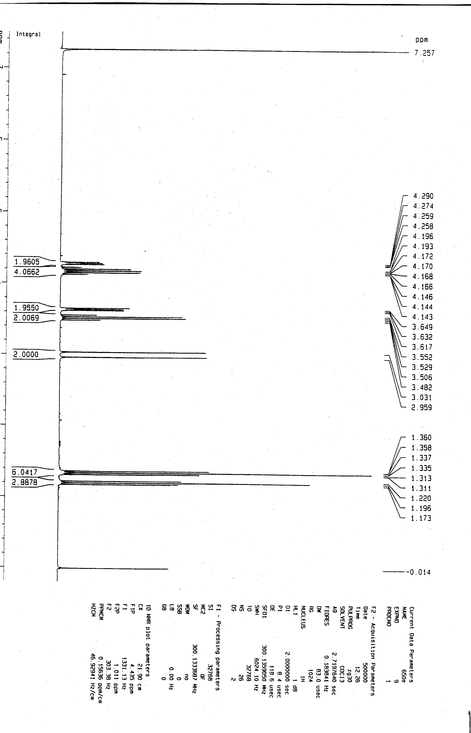

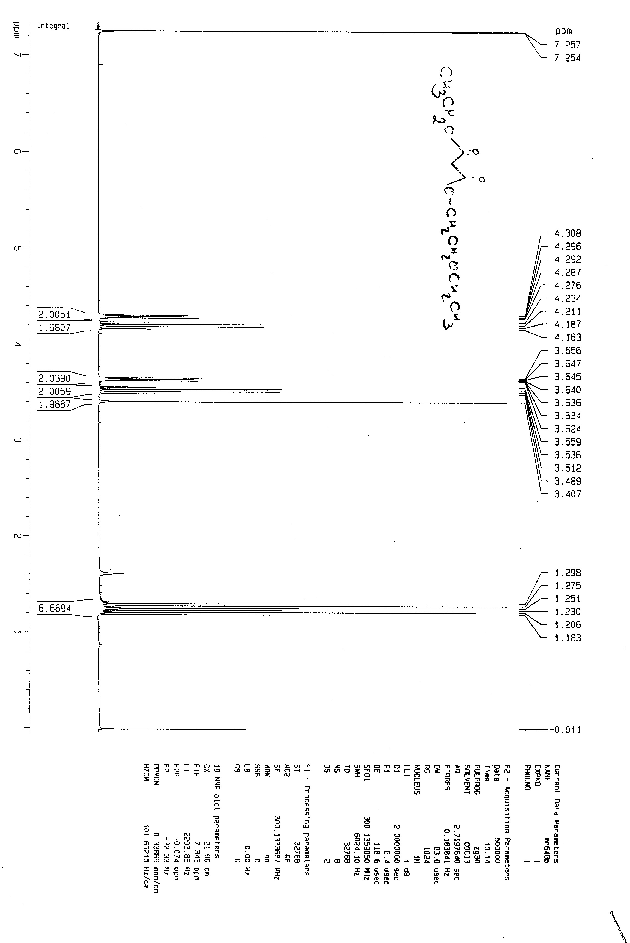

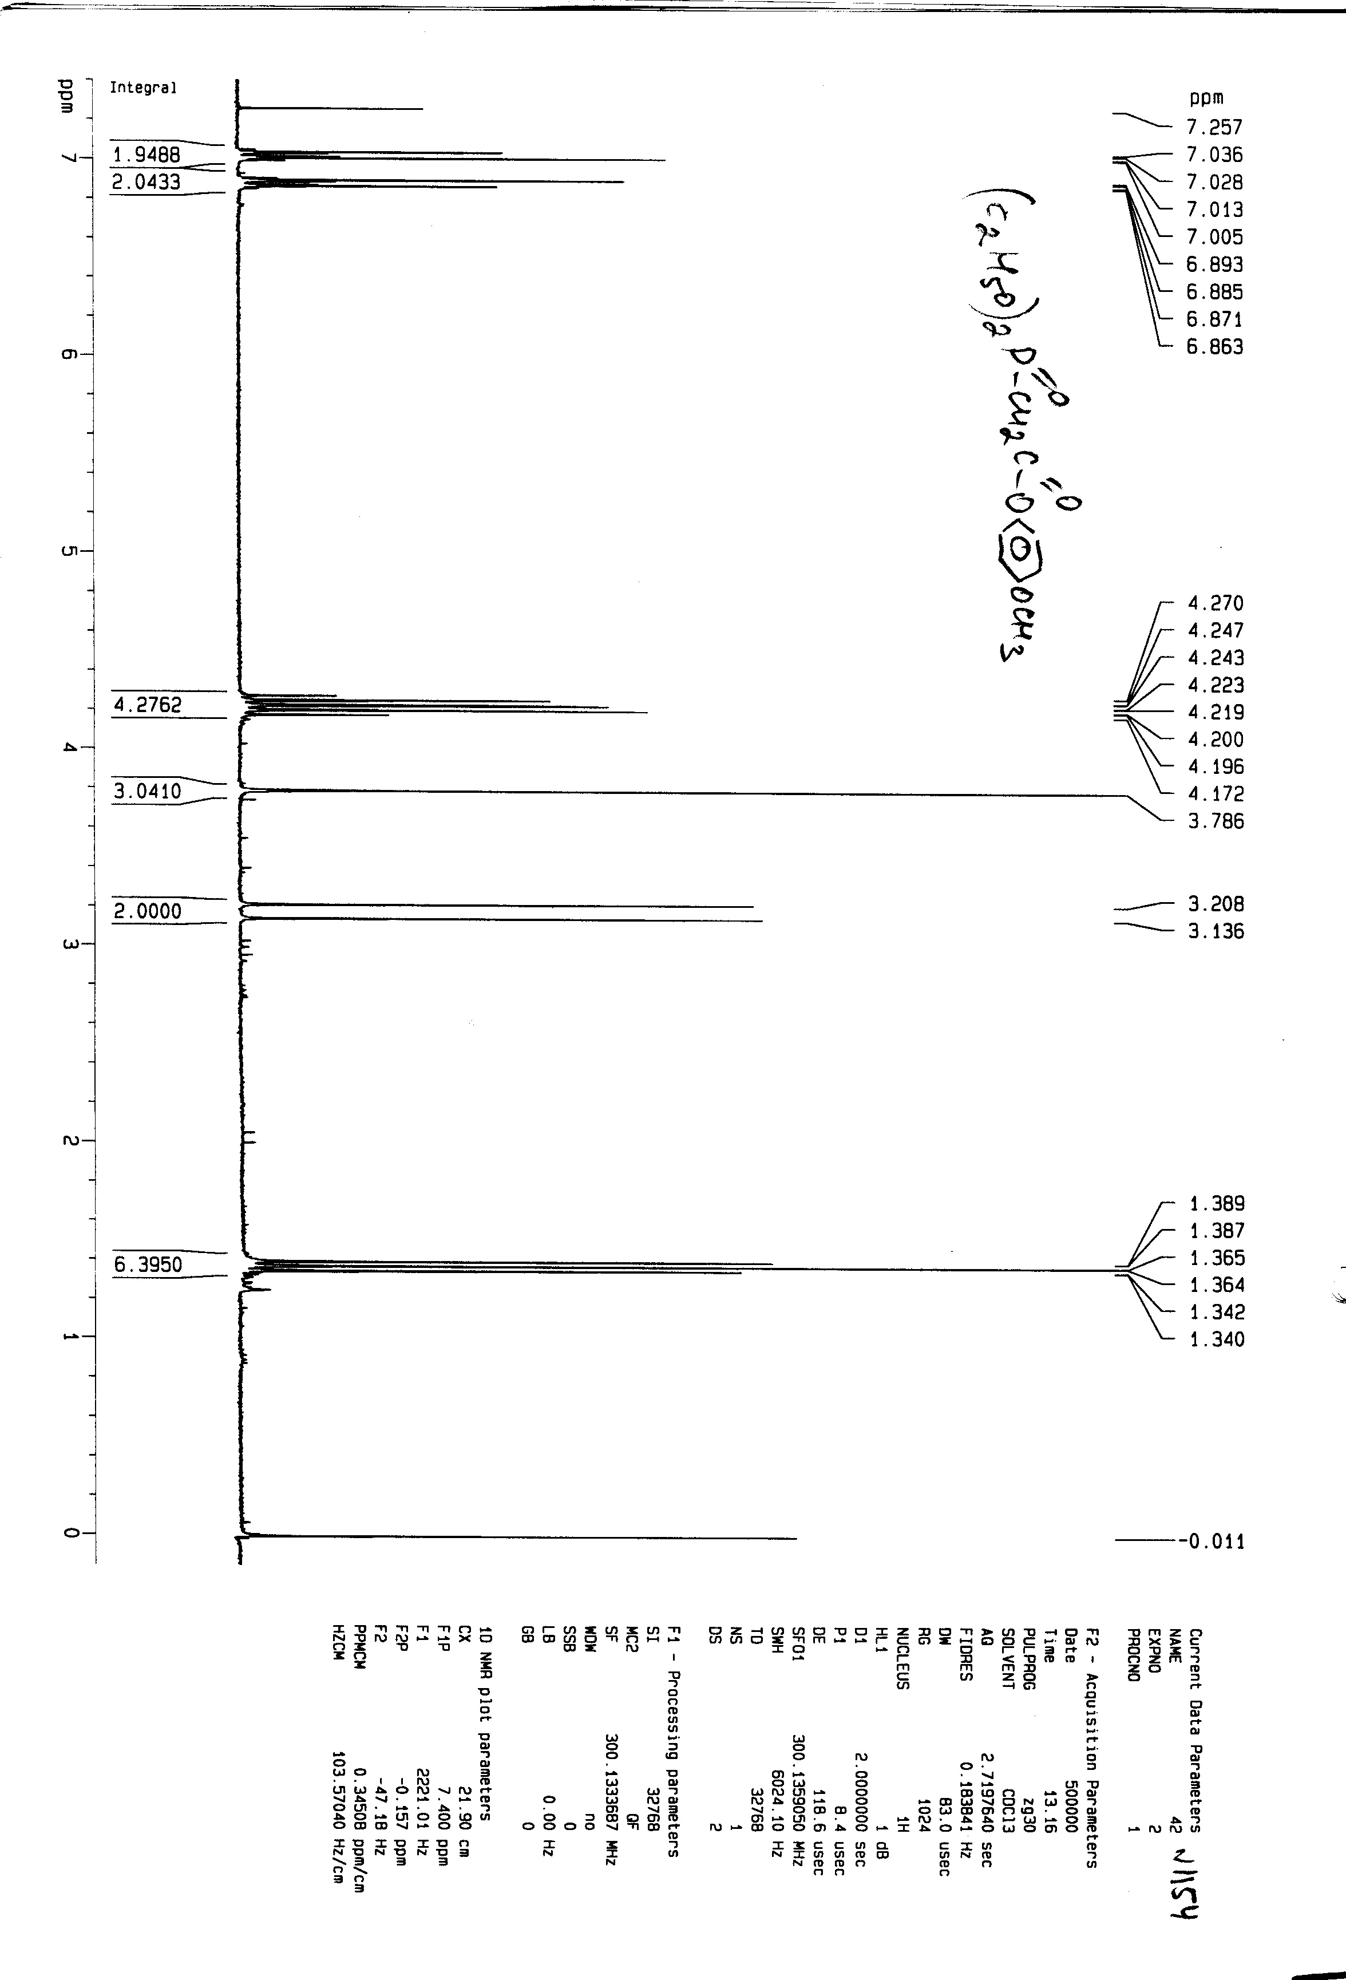

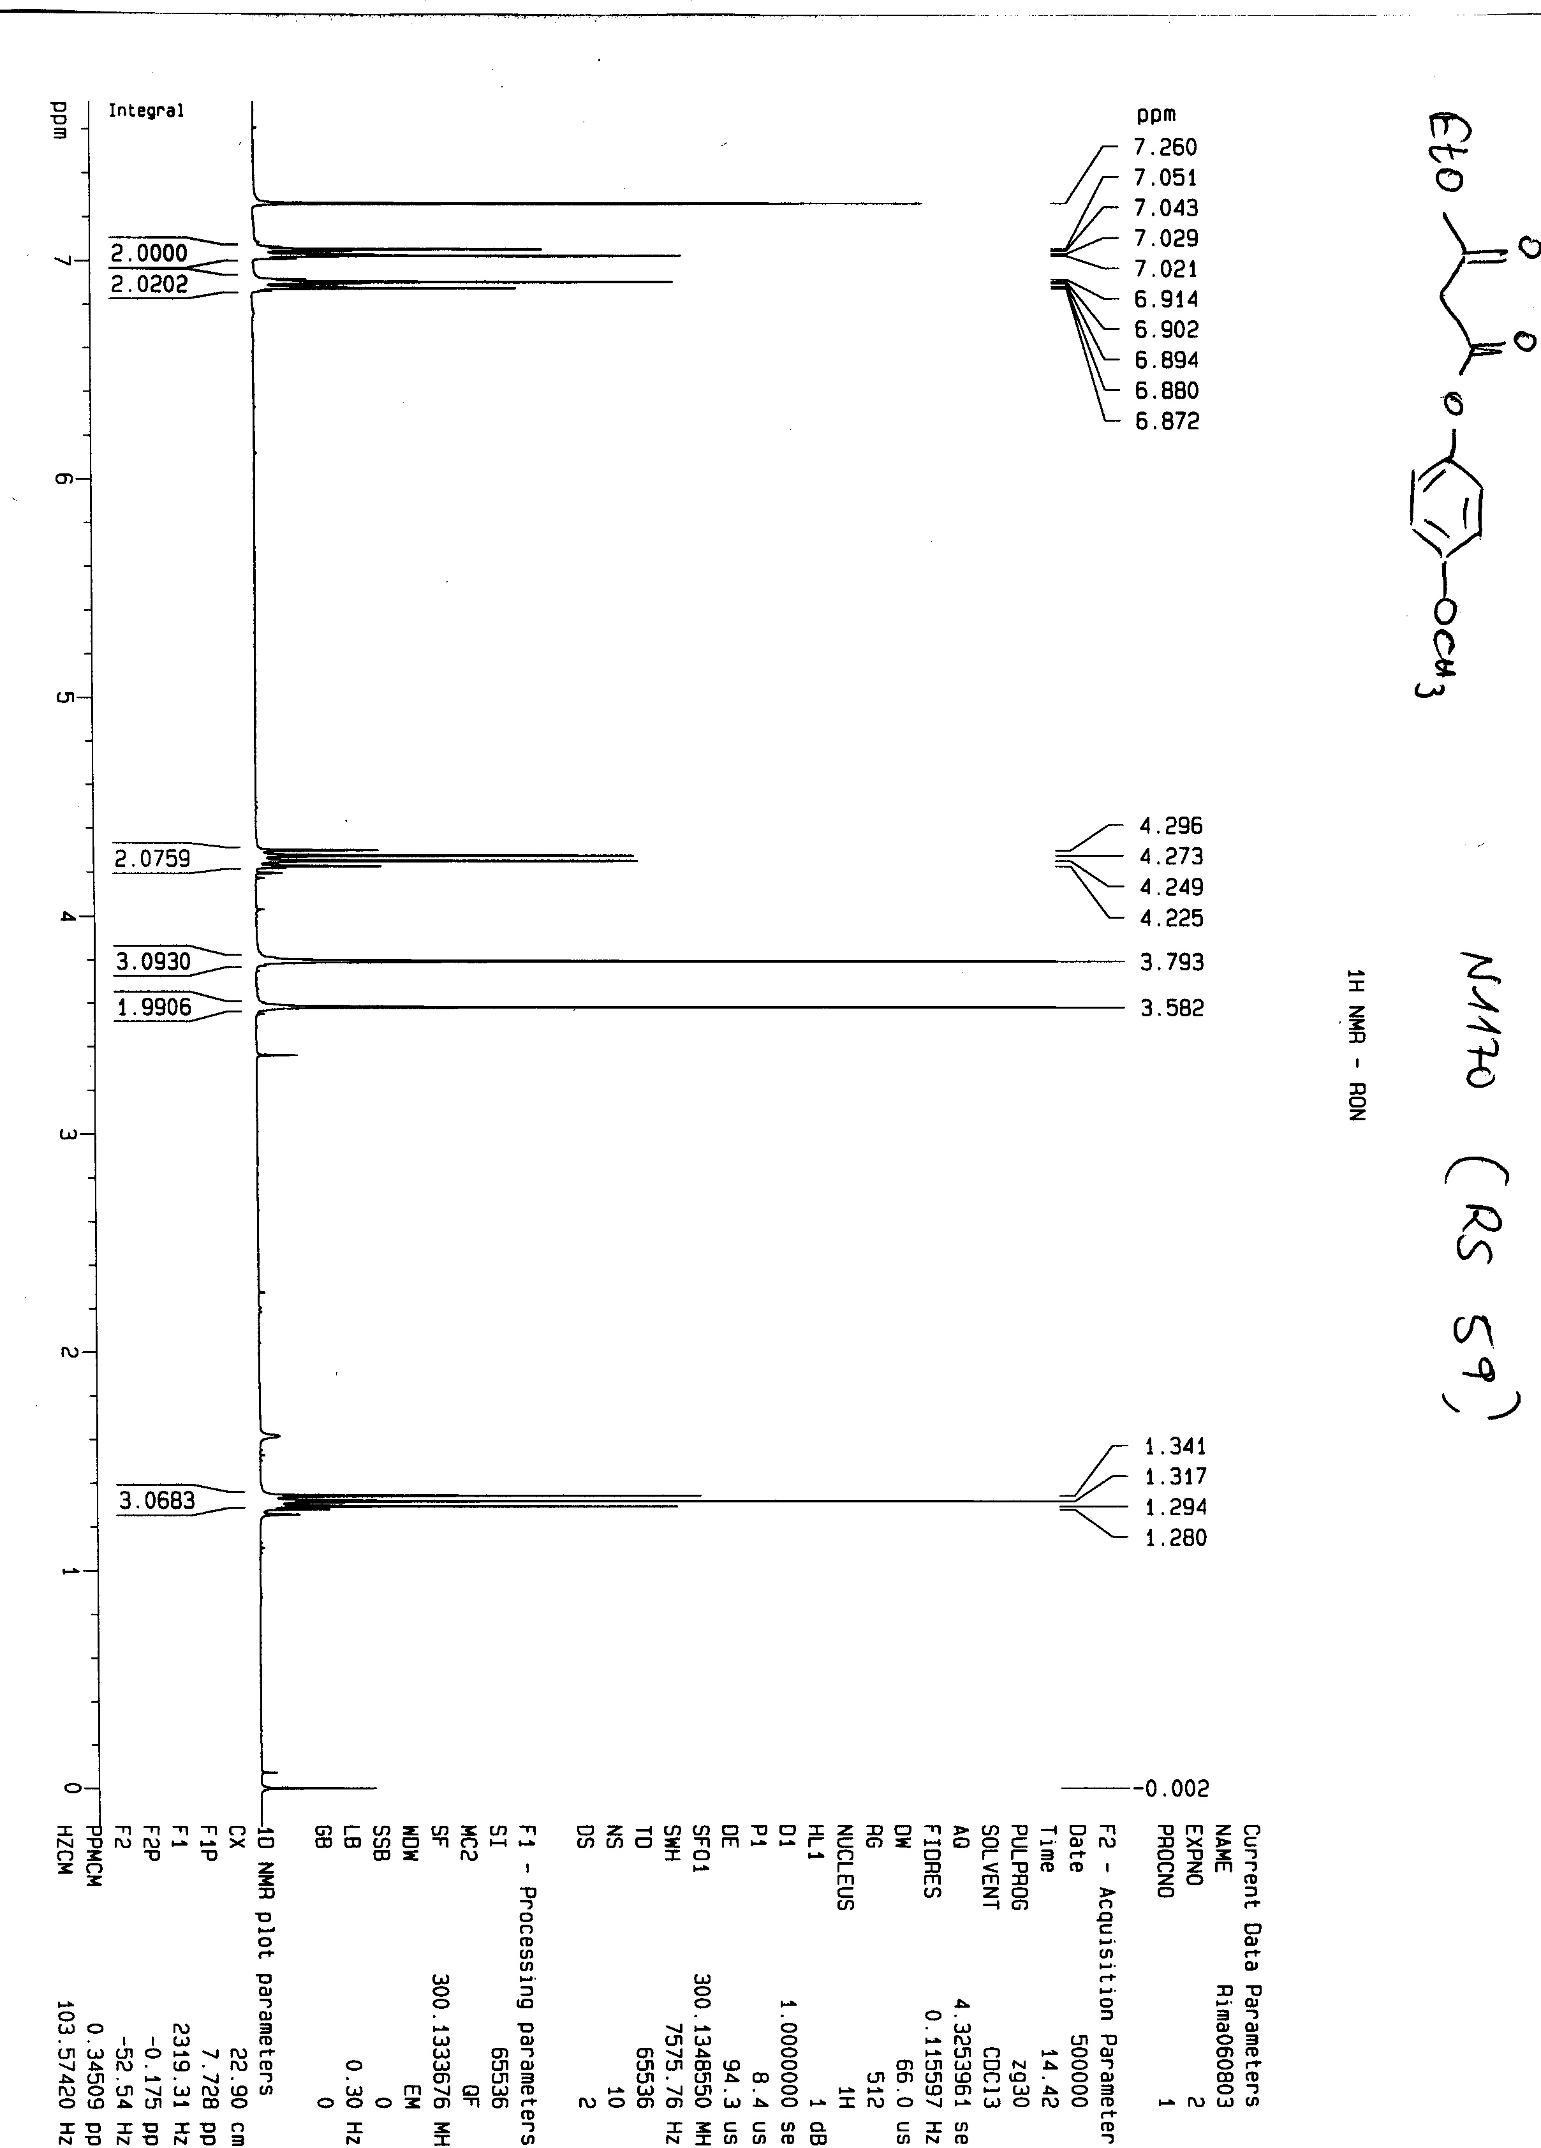

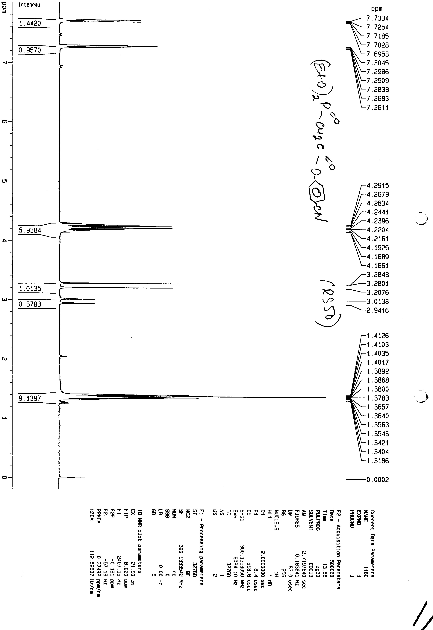
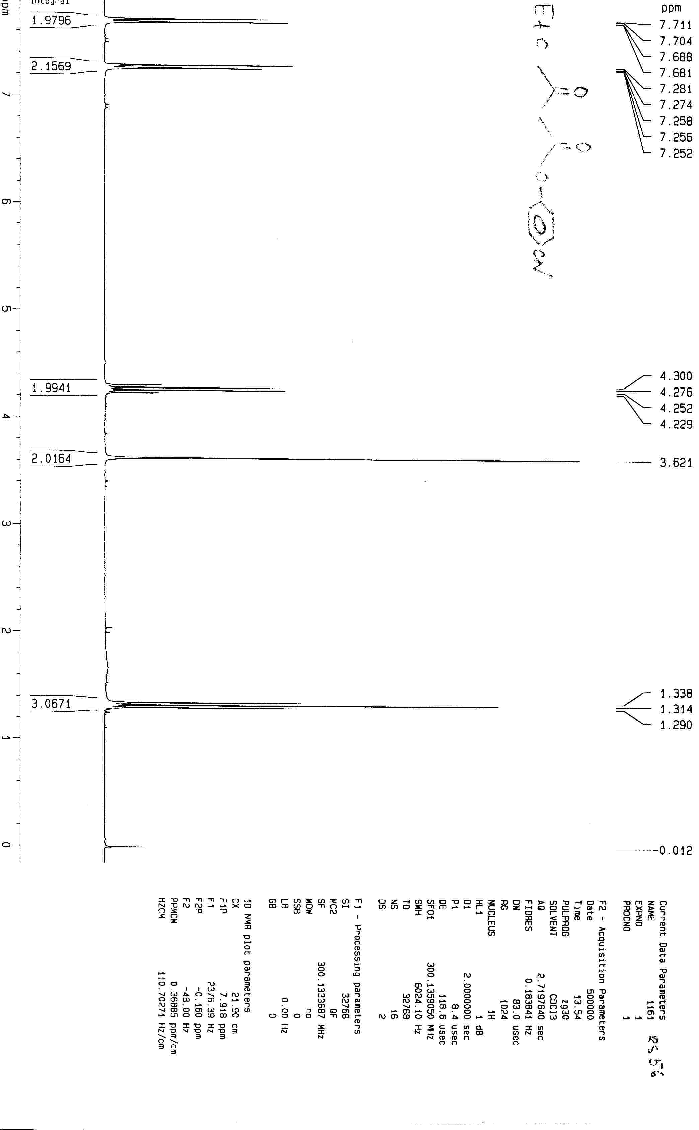
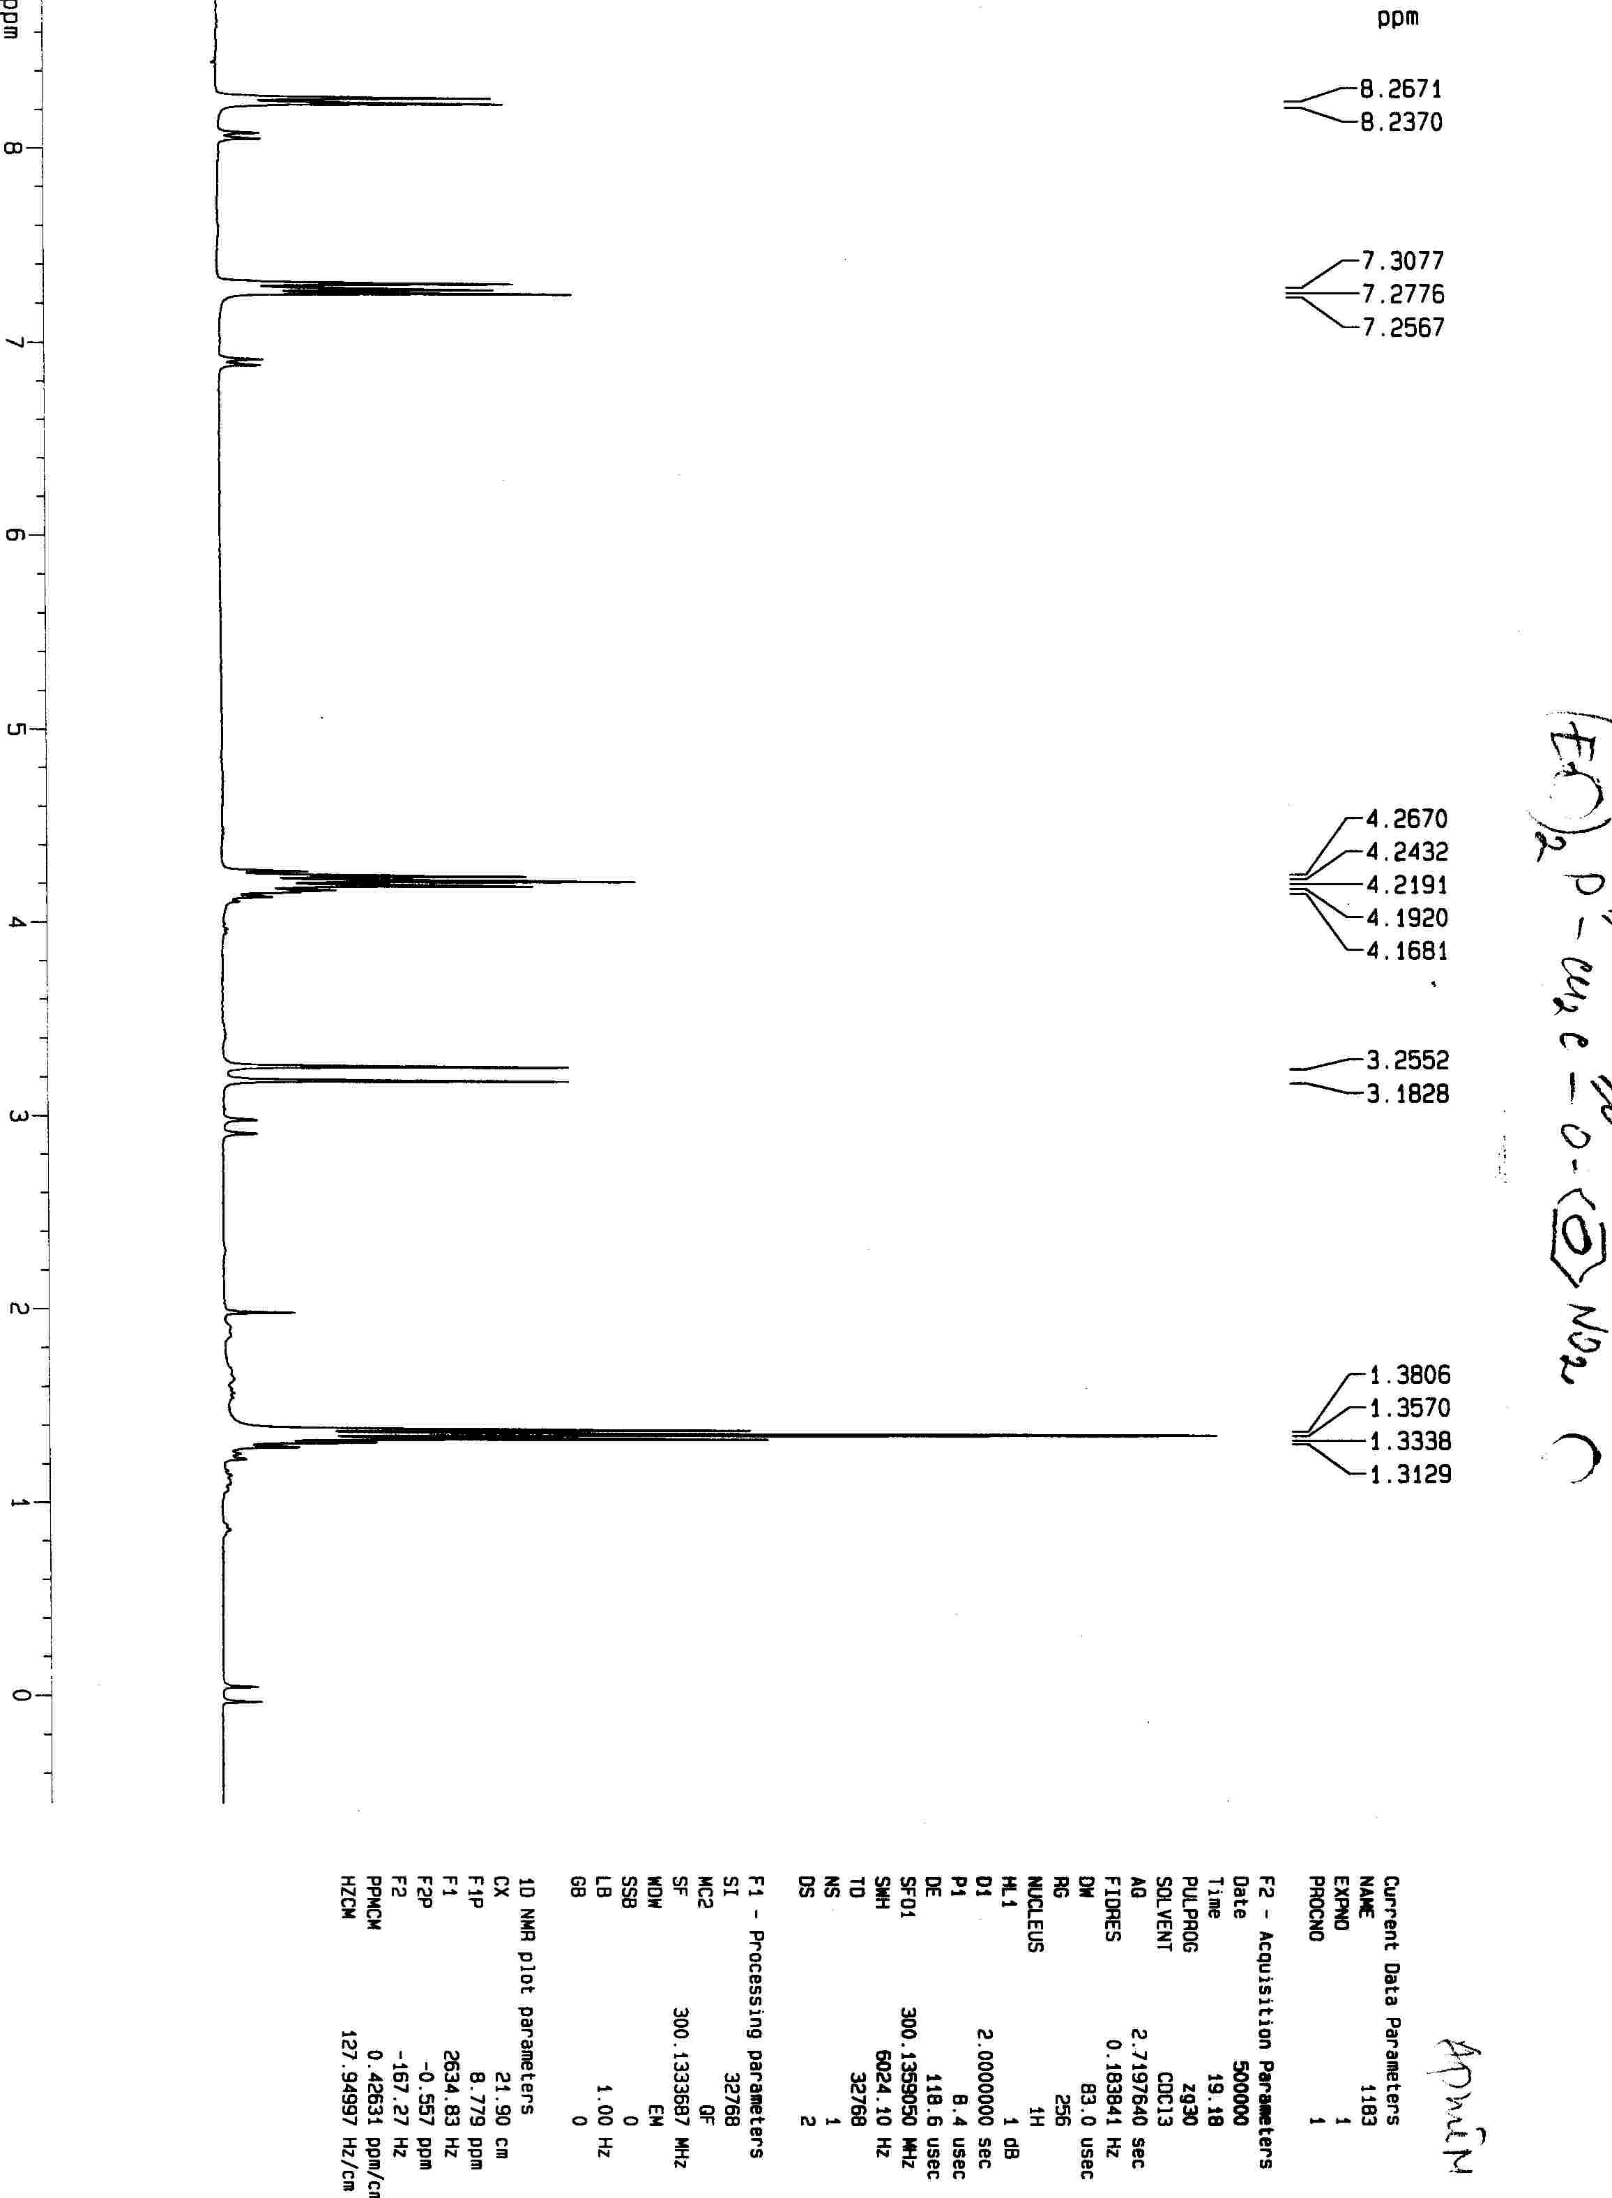

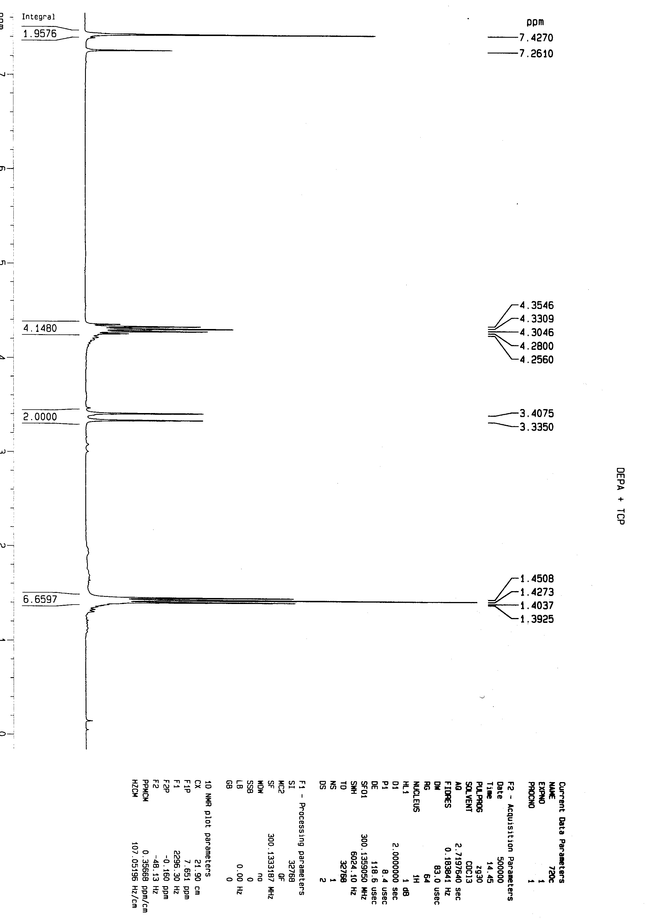

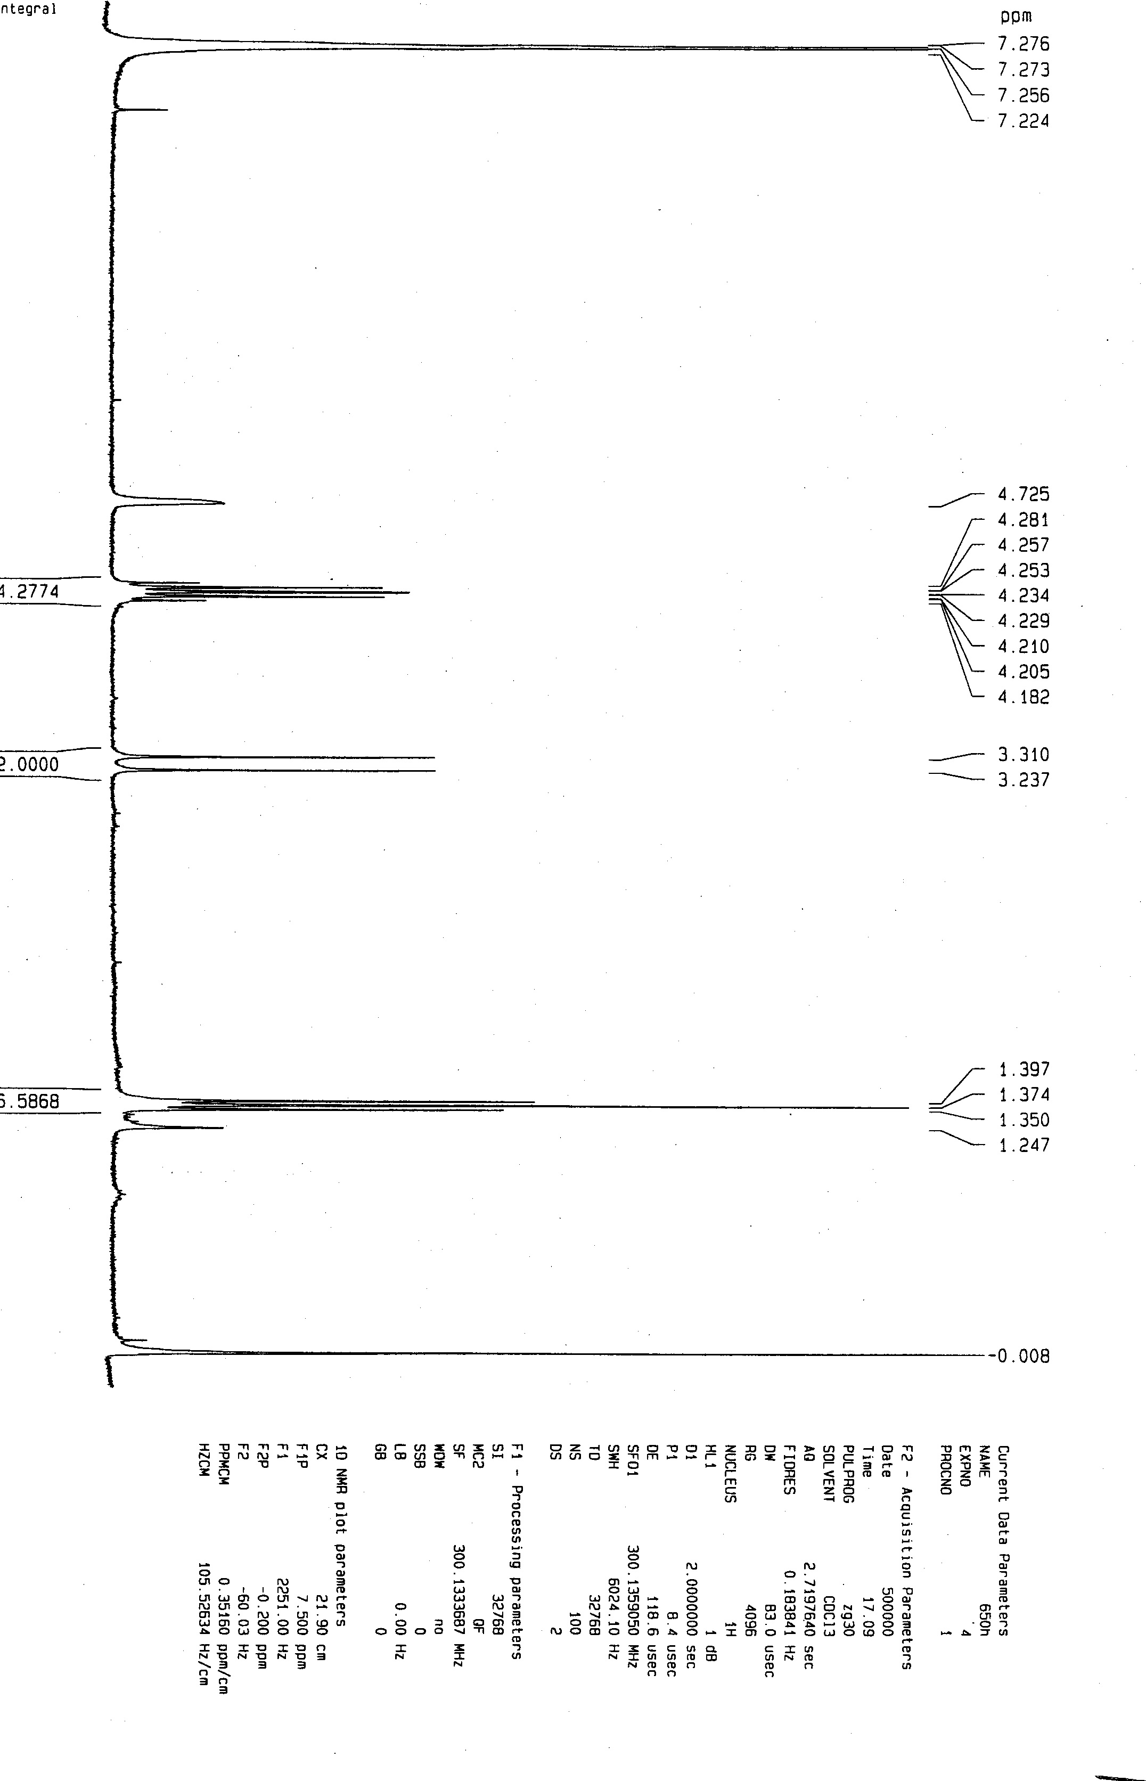
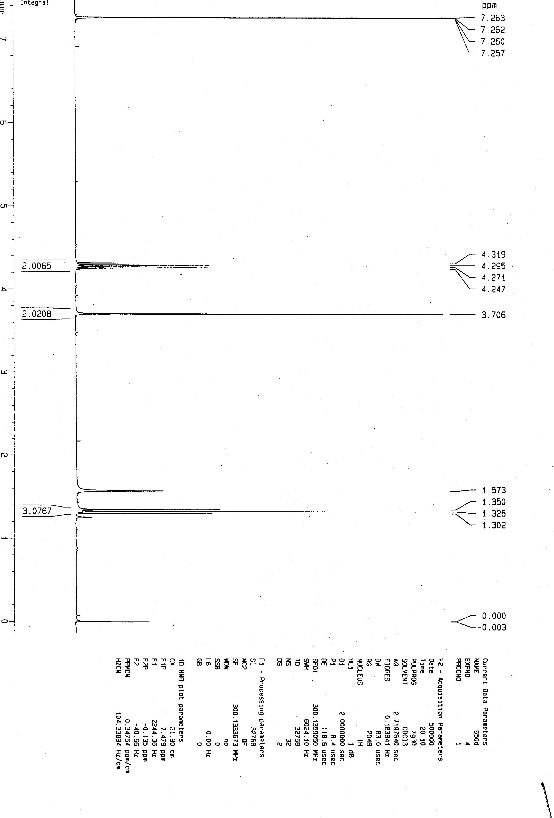

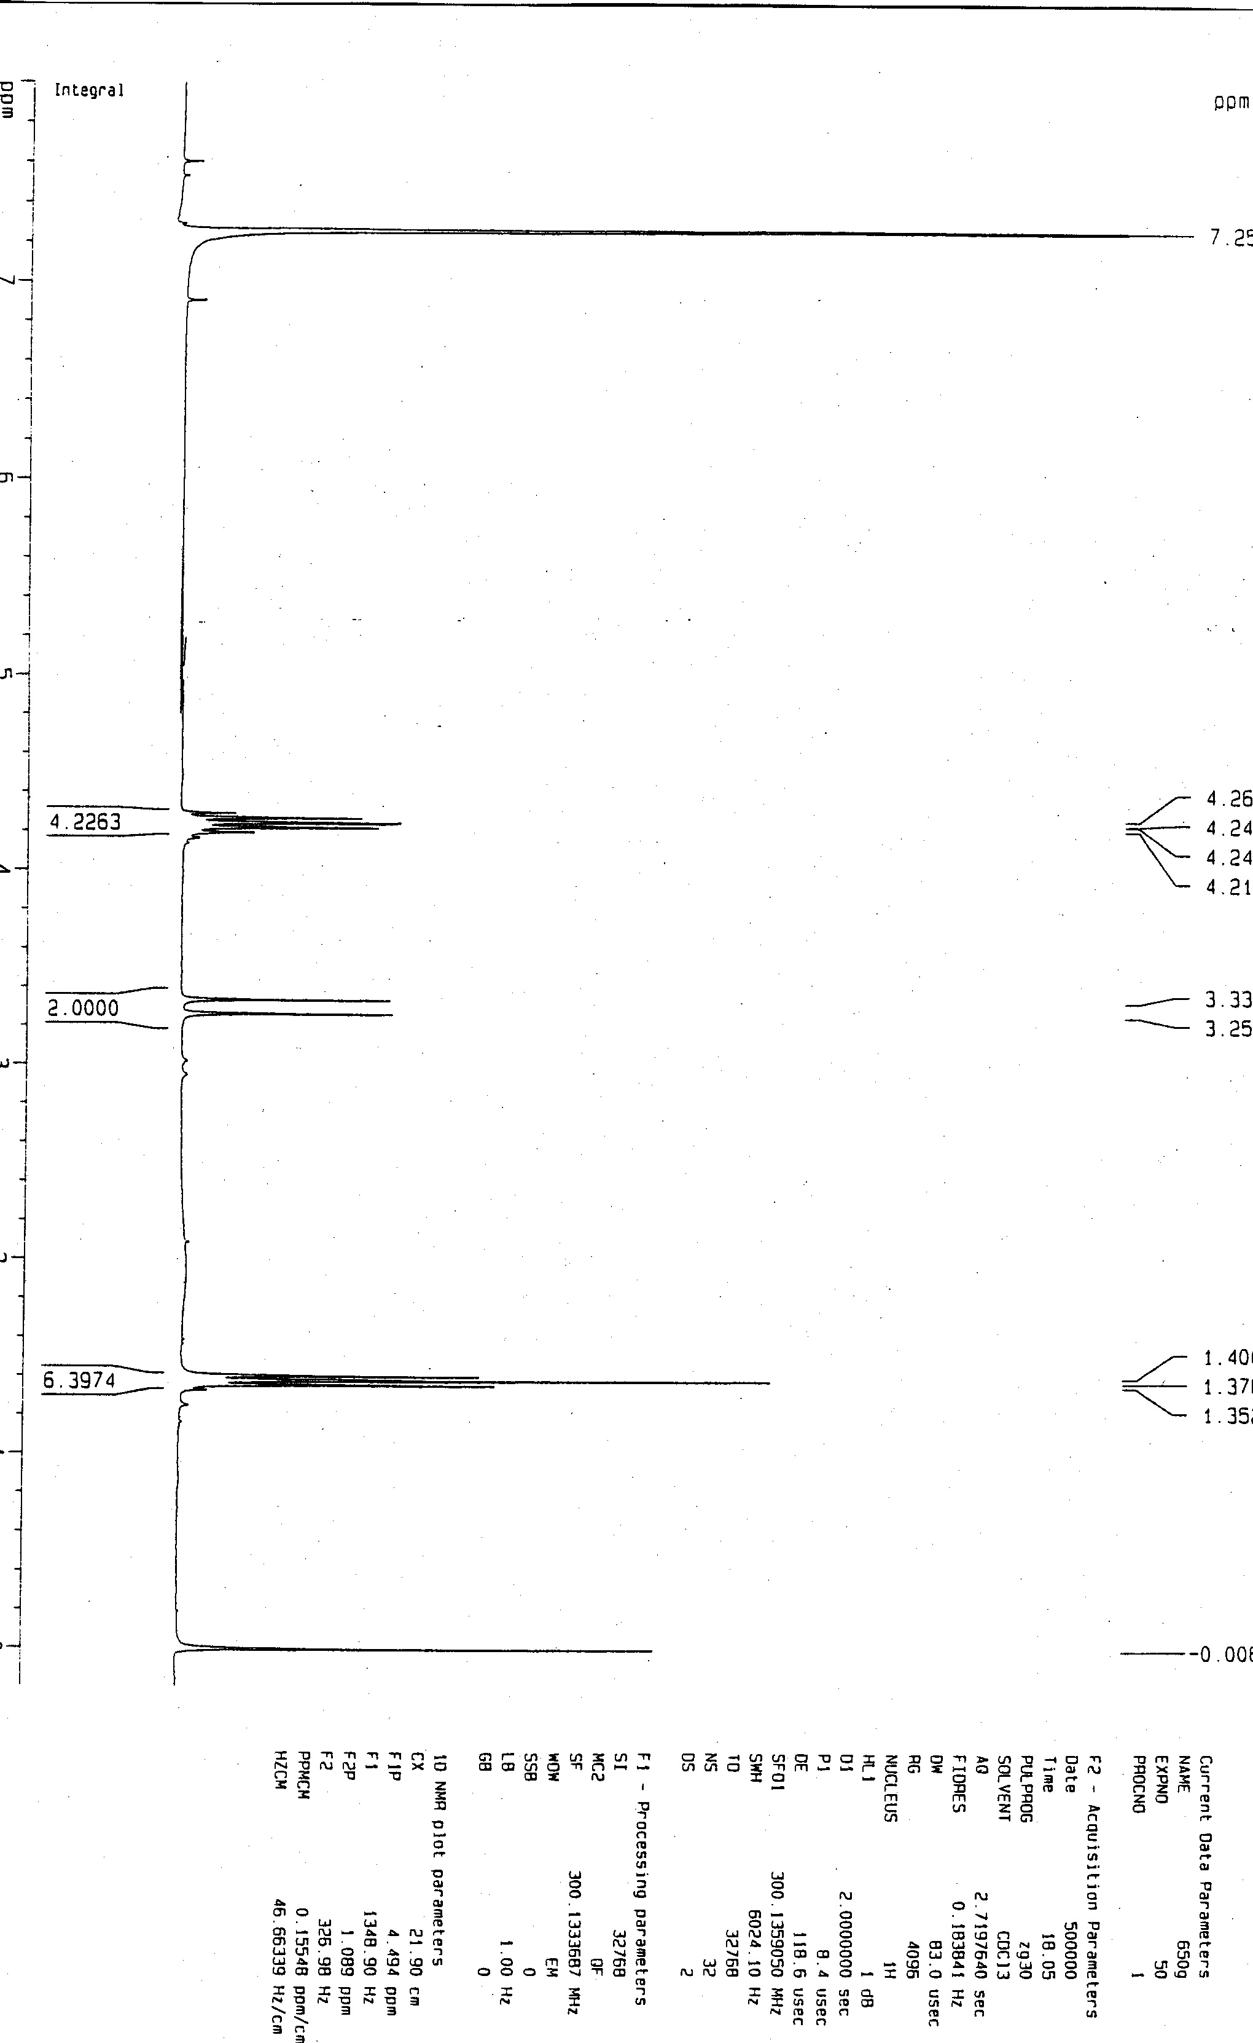
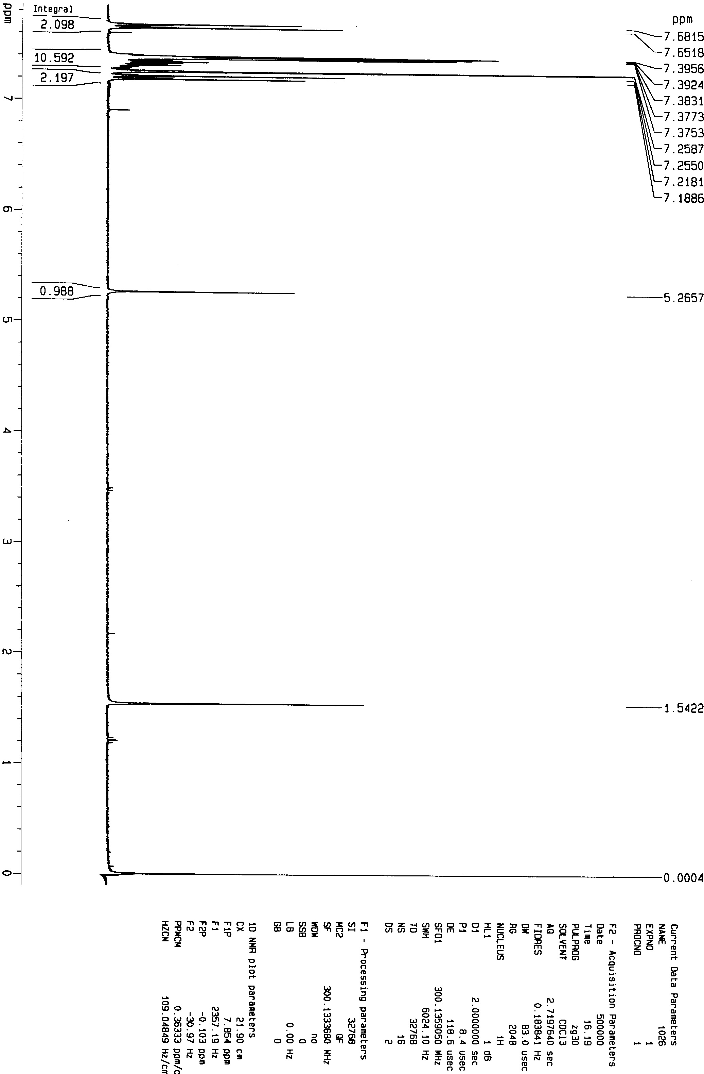

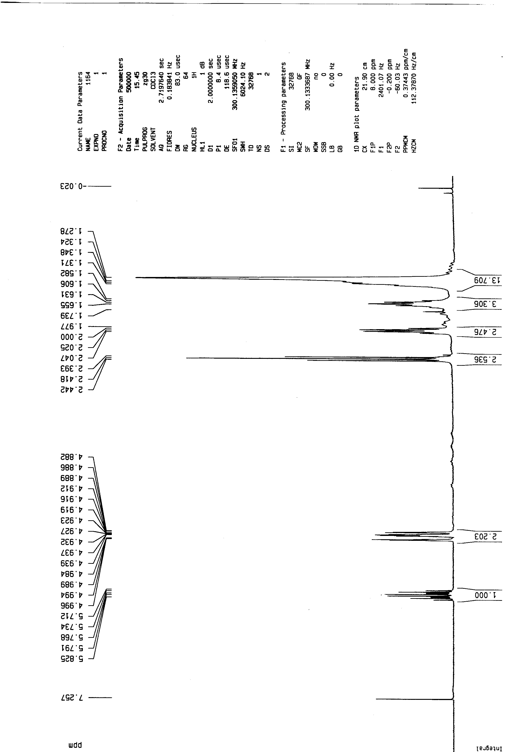
4H
4H
2H
4H
4H
20H

